**HADOOP IN CONTAINER WITH PERSISTENT STORAGE AND CONFIGURATION OF HDFS FILESYSTEM**

**#** *docker --version*

**Create a volume in docker to use as persistent storage**

**#** *sudo docker volume create --driver local --opt type=none –opt device=dockerVol –opt o=bind dockerVol*

**Pull Hadoop image**

**#** *docker pull westernscience/hadoop*

**Run container with persistent storage and proper port mapping**

**#** *docker run -d –name=kk_hadoop -v /dockerVol:/usr/local/hdfs/datastore -p 9870:9870 westernscience/Hadoop*

**Interactive shell**

**#** *docker exec -it kk_hadoop /bin/bash*



**Add Hadoop binary path as PATH environment variables**

**#** *vi ~/.bashrc*

export PATH=$PATH:$HADOOP_HOME/bin

**#** *source ~/.bashrc*

**Persistence volume inside container**

**HDFS Filesystem configuration**

**#** *hdfs dfs -ls /*

**#** *hdfs dfs -mkdir /MDS*

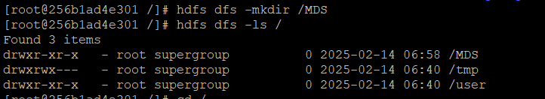

**#** *hdfs dfs -touchz /MDS/Bigdata.txt*

**Access DataNode Dahboard**

***https://<IP_address>:9870***

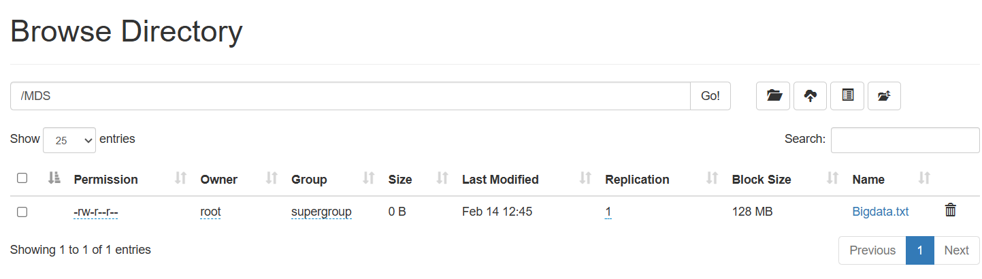

**#** *hdfs dfs –copyFromLocal /kk.txt /MDS/*

**#** *hdfs dfs -cat /MDS/kk.txt*

**#** *hdfs dfs -copyToLocal /MDS/Bigdata.txt /*

**#** *hdfs dfs -mv /MDS/kk.txt /MDS/13.txt*

**#** *hdfs dfs -du /MDS*

**#** *hdfs dfs -rm /MDS/13.txt*

